Activities
JOB-
When I finish my education, I would like to be a Chief Executive. A Chief Executive devises policies/strategies to make sure that a company/organization meets its goals. A Chief Executive also plans, directs, and coordinates the operational activities of public sector organizations/private sector organizations and companies. https://www.sokanu.com/careers/chief-executive/
I expect to get a Bachelor’s Degree in business, management, accounting, finance and economics. I expect to get a Master’s in Business Administration (MBA) as well. https://www.bestdegreeprograms.org/faq/what-is-the-best-degree-for-becoming-a-ceo
I would like to work for Talkdesk in San Francisco, California.
https://www.theladders.com/job/chief-of-staff-ceo-talkdesk-san-francisco-ca_38109032
The gross income for an entry level Cheif Executive Officer in San Francisco, California is $98.531. https://www.payscale.com/research/US/Job=Chief_Executive_Officer_(CEO)/Salary/85ccf330/San-Francisco-CA
Monthly the income would be $8210.91 before taxes are deducted. After taxes are deducted, the monthly income would be $6191.05 a month.
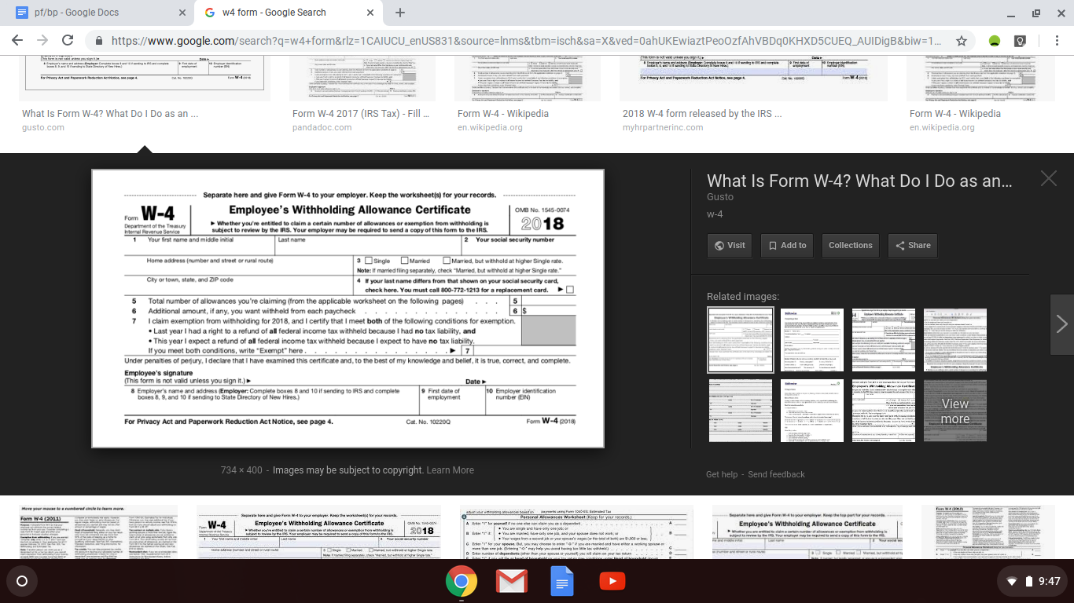
https://gusto.com/ask-gusto/payroll/form-w-4/
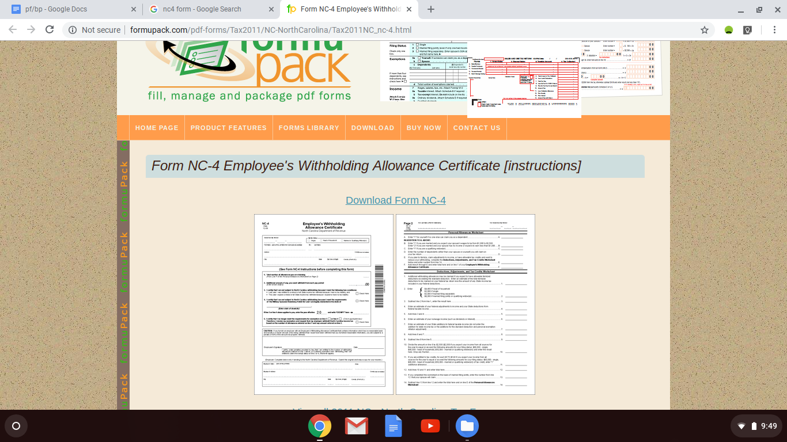
http://formupack.com/pdf-forms/Tax2011/NC-NorthCarolina/Tax2011NC_nc-4.html

BANK-
I will be using Bank of America to deposit my salary/wages. I will be using Bank of America because that’s what I have grown up using and I really like this bank. I’m also using this bank because they offer they offer fee waivers for eligible students under 24. I will be using the Bank of America Advantage SafeBalance Banking. That has a $25 opening deposit, no overdraft fees, and no paper checks. https://promo.bankofamerica.com/checkingforstudents/?cm_sp=DEP-Checking-_-Checking-_-DCTAHZ4101_Hero_NH_StudentChecking_WinterRush_checkingAccount
The monthly maintenance fee would be waived, there is 24/7 account access through mobile and online that lets you check balances, track expenses, set up email and text alerts, make deposits, and pay bills right from your phone or tablet, it allows you to send and request money from people on the mobile banking app, protects you with the $0 Liability Guarantee and a debit chip card that provides additional security for when it is used at chip-enabled terminals/ATMs, and debit cards can be temporarily locked (and can also be unlocked) through the app or online banking in order to help prevent unauthorized transactions.
https://promo.bankofamerica.com/checkingforstudents/?cm_sp=DEP-Checking-_-Checking-_-DCTAHZ4101_Hero_NH_StudentChecking_WinterRush_checkingAccount
You have to have a $25 opening deposit. There are no overdraft fees. There is no monthly maintenance fee. There is a $0 Liability Guarantee.
https://promo.bankofamerica.com/checkingforstudents/?cm_sp=DEP-Checking-_-Checking-_-DCTAHZ4101_Hero_NH_StudentChecking_WinterRush_checkingAccount
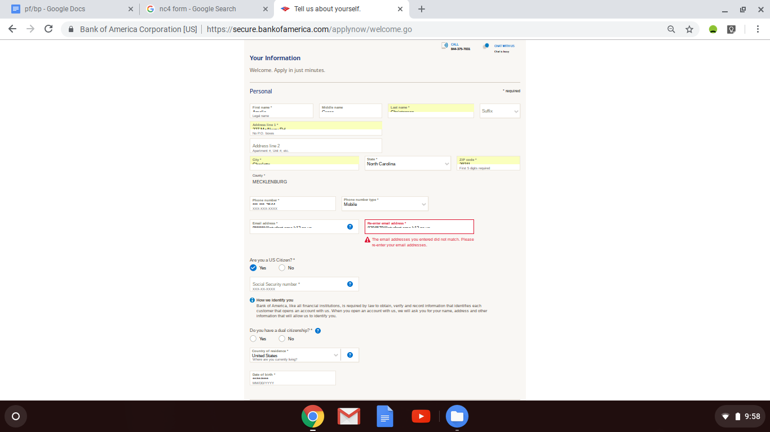
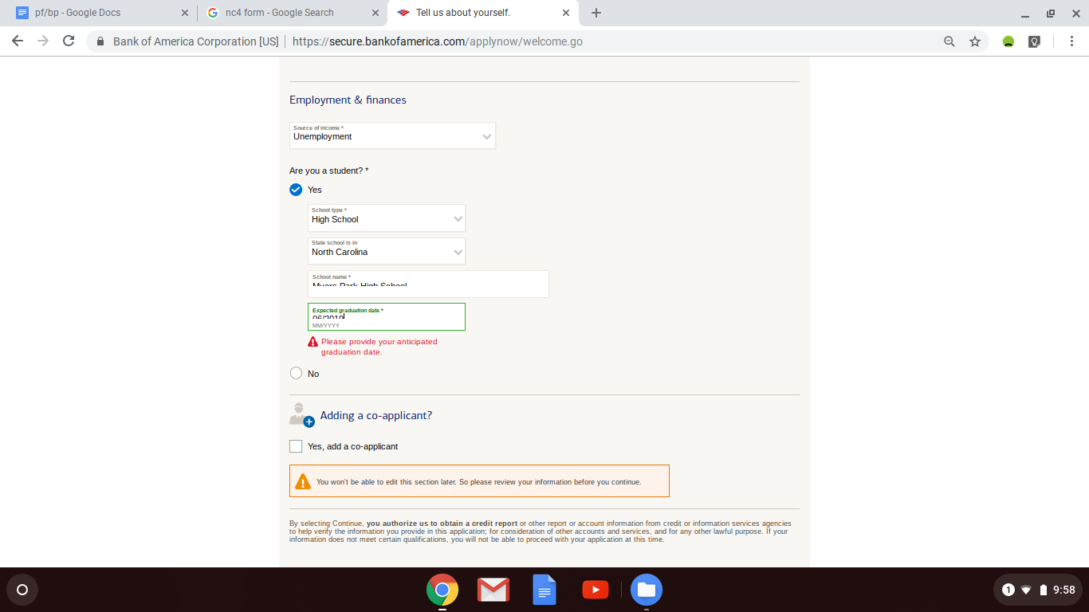
https://secure.bankofamerica.com/applynow/welcome.go
I talked with my parents and they said that they will pay for me to go to college. I feel very fortunate for this because I know it will take a huge burden off of my back. Because of this, I should not have any student loans. We have saved up money for me to go to college already, although they have stated that I am not to disclose the amount of which is saved as they say, and I agree, that this is private information.

HOUSING-
The services/benefits included in the rent include heat, a resident lounge with free Wi-fi, laundry facilities, doorman, concierge, courtesy patrol, maid service, online services, composting, a gated outdoor space, a fitness center, cardio machines, bike storage, high speed internet access, cable ready, wheelchair accessible (rooms), a dishwasher, disposal, microwave, oven, range, refrigerator, and a property manager on site.
The location of the appartment is 1188 Mission St, San Francisco, CA 94103 at Trinity Place unit number 1722 and it costs $2964 a month.
Other information necessary for housing include an unassigned garage parking recurring fee of $275 minimum (with a one-time application fee of $49) as well as pets not being allowed.
https://www.apartments.com/1188-mission-at-trinity-place-san-francisco-ca/dm9e9kl/
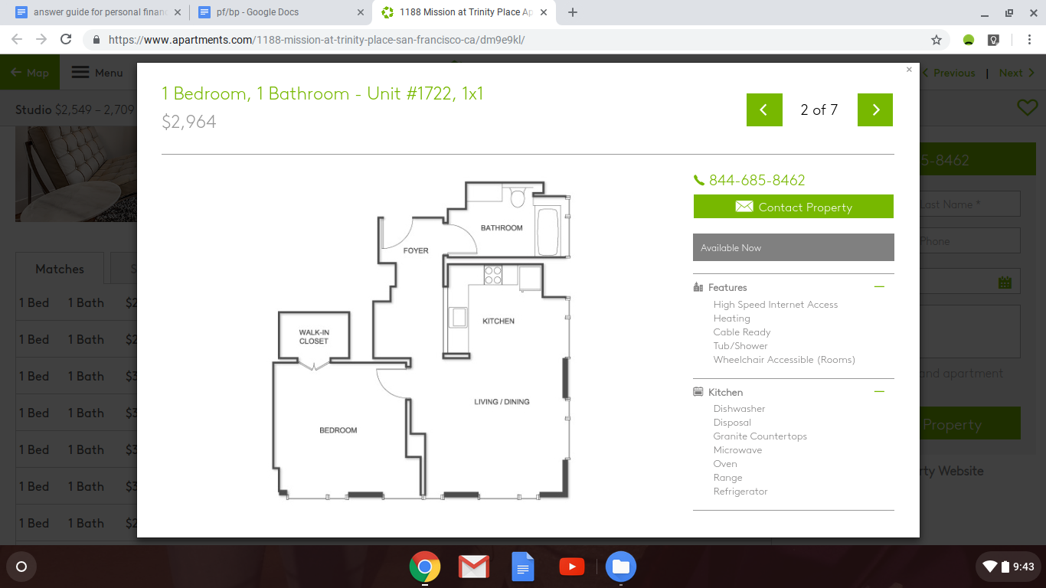
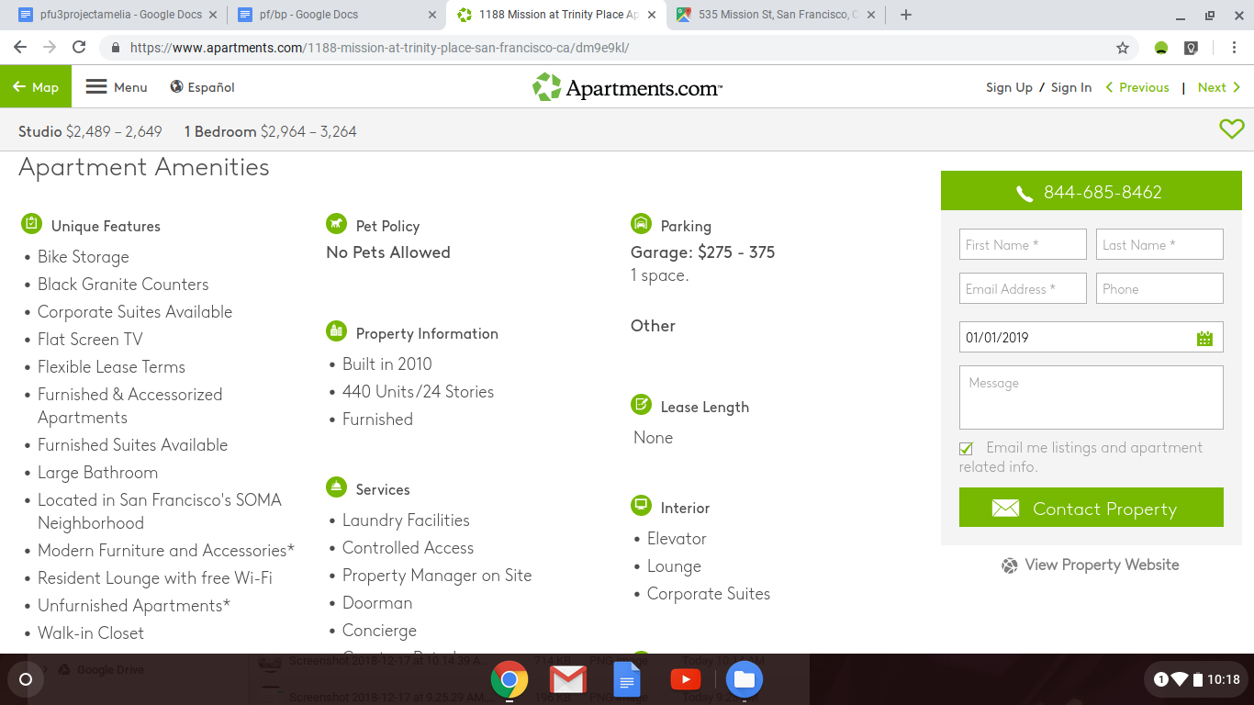
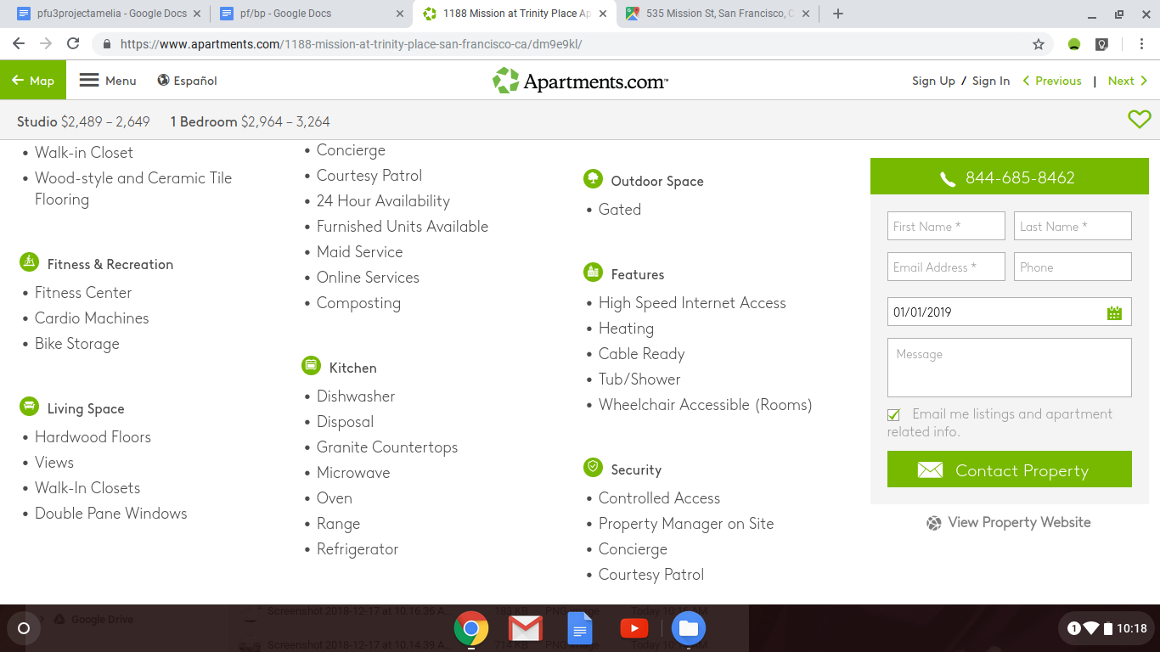

TRANSPORTATION-
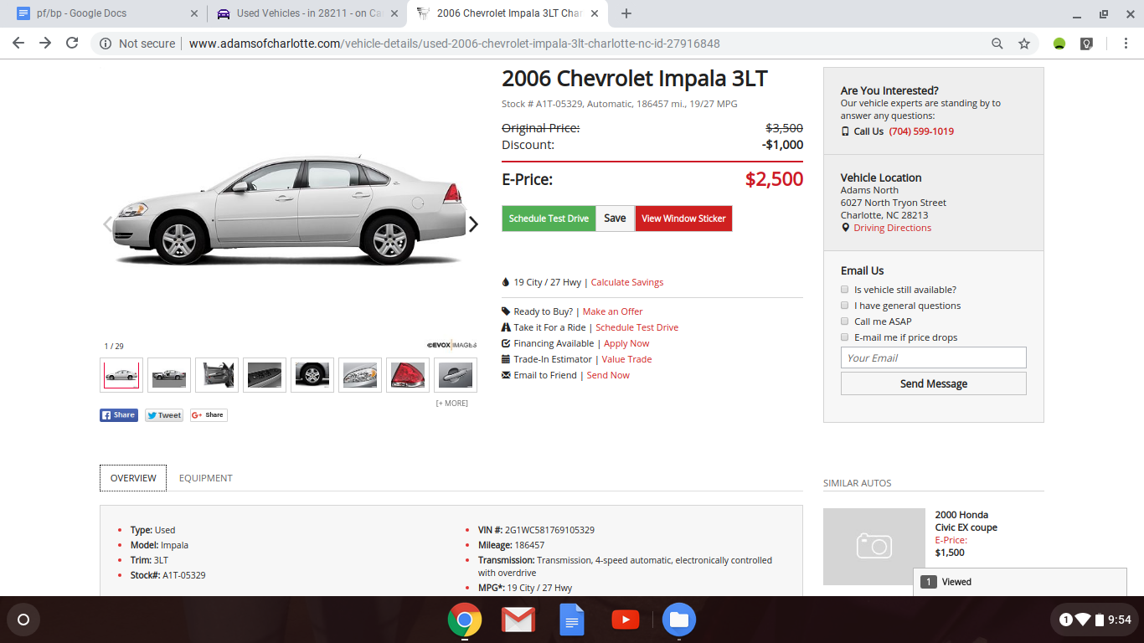
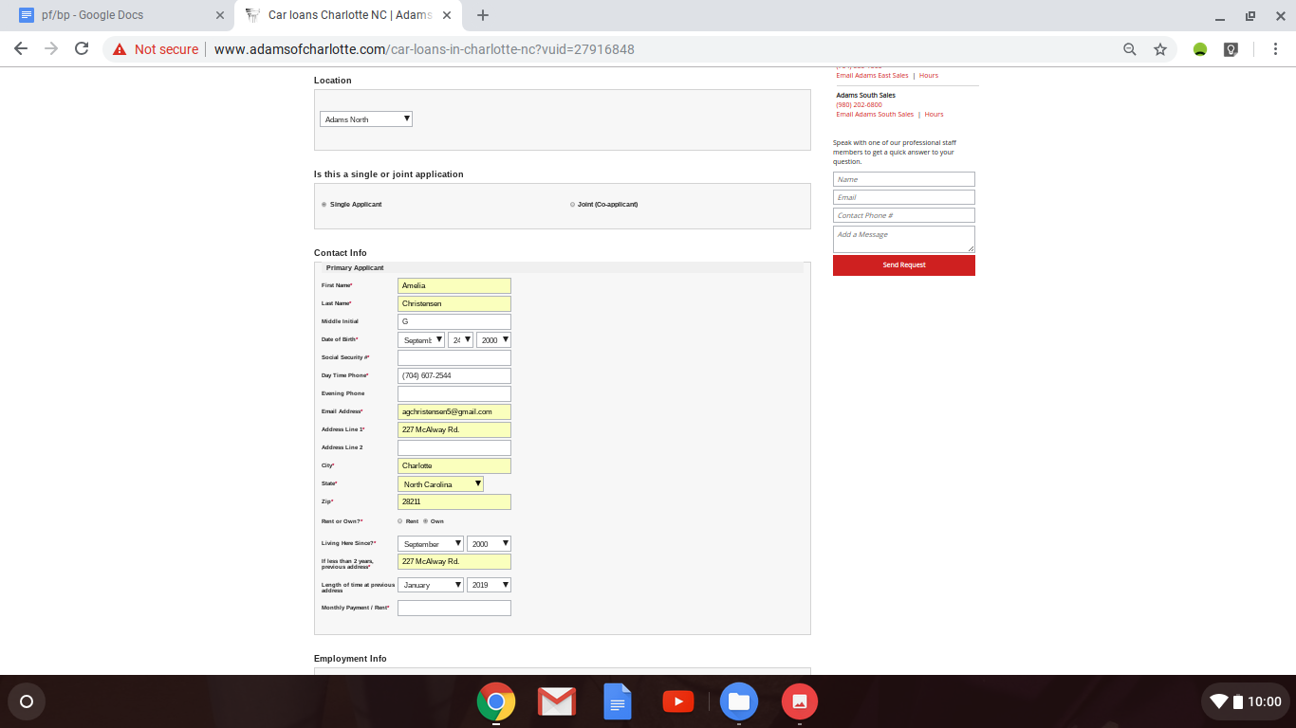
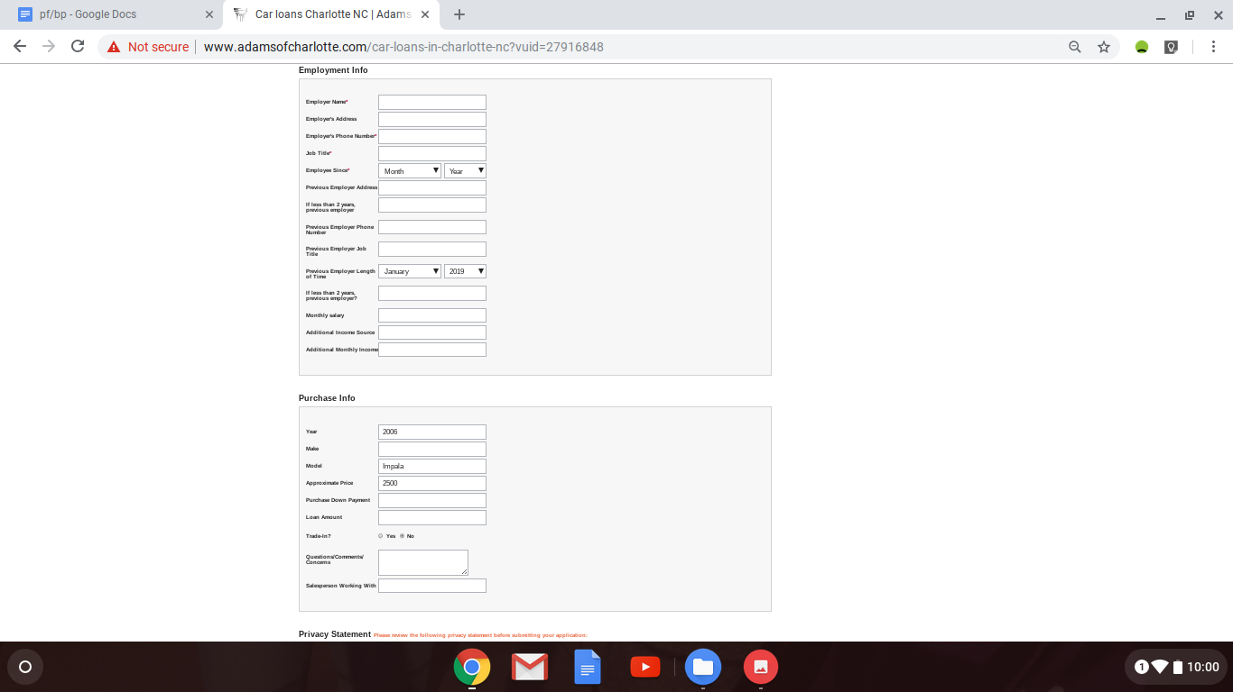
http://www.adamsofcharlotte.com/car-loans-in-charlotte-nc?vuid=27916848
http://www.adamsofcharlotte.com/vehicle-details/used-2006-chevrolet-impala-3lt-charlotte-nc-id-27916848
The US national average interest rates are 4.21% for 60 month loans for auto loans. The annual percentage rate is anything from 3%-10% for auto loans.
https://www.valuepenguin.com/auto-loans/average-auto-loan-interest-rates
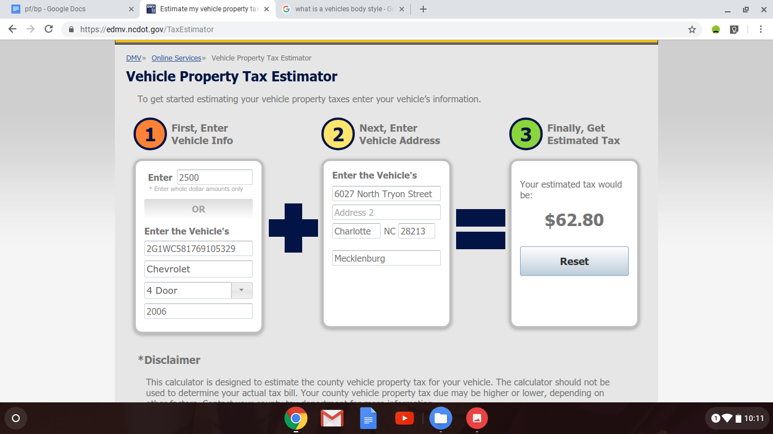
My estimated tax would be $62.80. https://edmv.ncdot.gov/TaxEstimator
The car costs a total of $2,500. $2,500 over 12 months would be approximately $208.34 a month. With the estimated tax that would be $271.14.

INSURANCE-
The insurance company that I will be using is Progressive. I have chosen to use progressive because they have the best rates in my area.
https://www.valuepenguin.com/insurance/results?src=_average-cost-of-insurance&mobile=false&ma=true&insType=auto&zip=28211&age=16&prior=1
I will have liability coverage for my vehicle. This is required to have by law and financially protects me when I am liable for my actions as a driver. It protects me if I’m at fault in an accident. Their average monthly price is $137.
https://www.progressive.com/answers/average-car-insurance-cost/
I will also be using progressive for renter’s insurance. Renter’s insurance is property insurance that gives coverage for properties in someone’s apartment just in case something happens. The smallest average renter’s insurance policy from Progressive is $13 per month.
https://www.progressive.com/answers/average-renters-insurance-cost/
My auto and renter’s insurance together would be $150 a month.

CELL PHONE/TELEPHONE-
The company I will be using is Verizon. The monthly cost for my plan is $55 a month for 5GB and includes Premuim 4G LTE Data, Unlimited Talk and Text, Carryover Data, Safety Mode, Data Boost $15/1GB, and Verizon Up Rewards. This plan also includes a $20/mo/line access fee per smartphone purchased on device payment plus taxes and fees. The total amount each month would come out to be $75 a month.
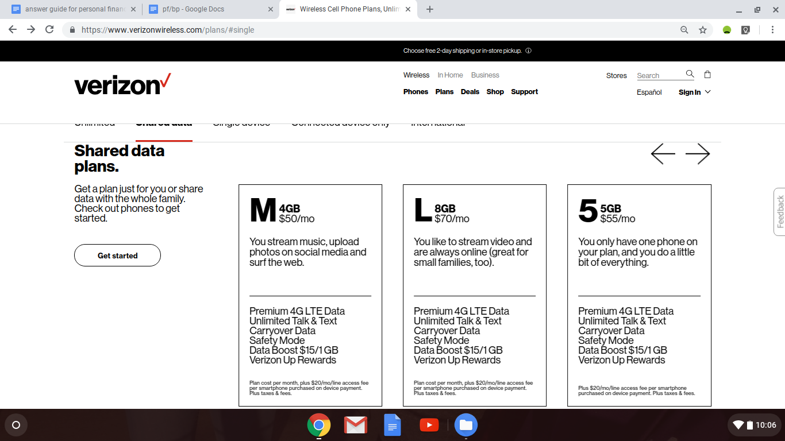
https://www.verizonwireless.com/plans/#single

UTILITIES-
Heating, free Wi-fi, laundry facilities, online services, composting, high speed internet access, is cable ready, dishwasher, disposal, microwave, oven, range, tub/shower, and a refrigerator are all included in the housing arrangement, so I will not have to pay for cable, online services, electricity, trash, water, or others.

FOOD AND CLOTHING-
I will spend $160 a month on food. My shopping will be done at the Safeway located at 298 King St, San Francisco, CA 94107 because I have had pleasant experiences at Safeway before and it is only 1.5 miles from where I’m living.
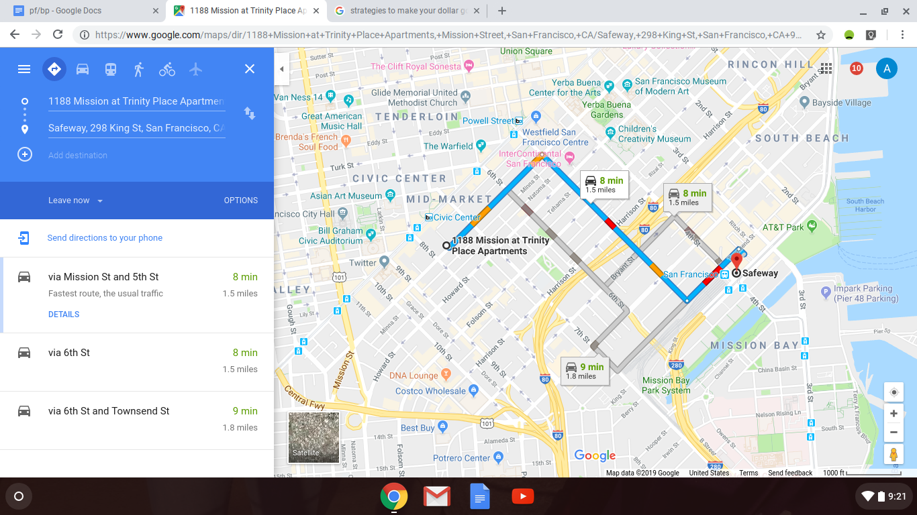
Strategies that I will use to make my dollar go further include making a shopping list and sticking to it, checking for specials, plan out meals ahead of time, stocking up on staples when/if they go on sale for a good price, and using coupons when possible.
https://www.igrad.com/articles/10-day-to-day-savings-tips
https://www.cnbc.com/2015/04/23/here-are-20-easy-ways-to-save-some-money-every-day.html
https://www.morningstar.com/articles/750108/100-ways-to-cut-your-daytoday-expenses.html

The type of clothing that will be required for my chosen profession is business casual attire. I will likely spend $160 a month on clothing. https://www.creditdonkey.com/average-cost-clothing-per-month.html

ENTERTAINMENT/MISCELLANEOUS-
For netflix I will continue to watch through my parents account as they have a plan at a reasonable price that accommodates our whole family and they are planning to keep. In return for letting me use their account I will pay them $4 a month.
I really enjoy/have fun exercising so I can go on runs around my neighborhood, which doesn’t cost a thing!
Netflix is important to me because it helps me take my mind off of things and unwind.
Exercising/running is important to me because it is a good way to stay in shape, its healthy, it helps me take my mind off of things, and it’s free.
Volunteering is important to me because it makes me happy and allows me to give back and get to know other people in the community. The only thing that it costs is time, so it is essentially free.
All of the above activities are financially wise. I chose them as oppossed to other things because they are low cost and make me happy. Putting time into myself and living an active lifestyle is very important to me and I find pleasure in it. Although I’m not really saving for any big purchases, as I would certainly not call myself a big spender, I don’t really like paying for things that aren’t really necessary.
I don’t think that I really need to use any strategies to make my dollar go further here, as I didn’t really spend that much and there isn’t much to really cut back on the way I see it.

GASOLINE CONSUMPTION-
I will drive approximately 115 miles per week. Everything is in pretty close proximity to where I will be living, which is pretty nice.
For miles per gallon my car averages 19 for city and 27 for highway.
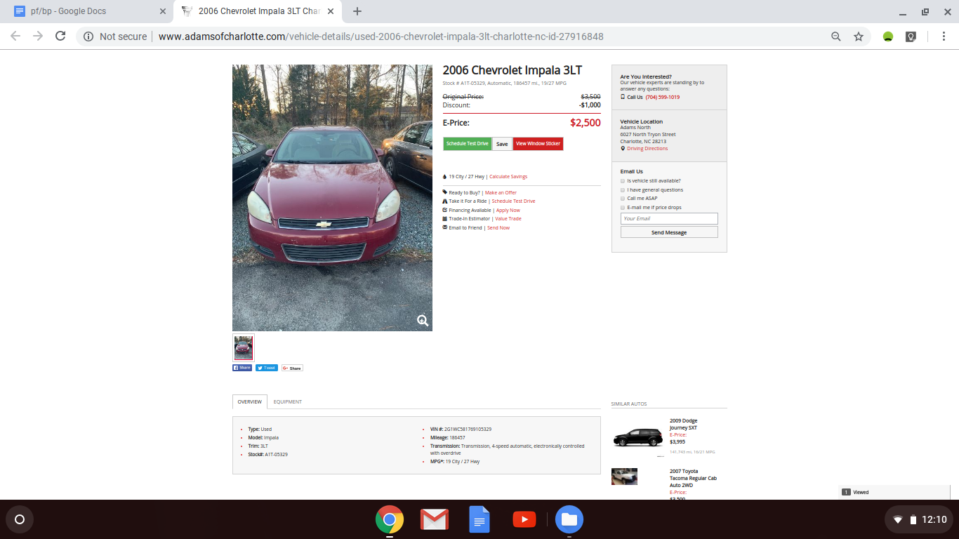
http://www.adamsofcharlotte.com/vehicle-details/used-2006-chevrolet-impala-3lt-charlotte-nc-id-27916848
The estimated maintenance costs for my car is $238. The car will likely need oil changes. Other common needs of a Chevrolet Impala include differential/gear oil replacement, CV Axle/Shaft assembly replacement, ball joint replacement (front), headlight bulb replacement, steering rack/gearbox replacement, spark plug replacement, front crankshaft seal replacement, control arm assembly replacement, window motor regulator replacement, intake manifold gaskets replacement, cabin air filter replacement, car battery replacement, oxygen sensor replacement, fuel filter replacement, exterior car door handle replacement, windshield wiper motor replacement, braker rotors/ discs replacement, power steering pressure hose replacement, engine or transmission mount replacement, car radiator replacement, brake caliper replacement, and water pump replacement.
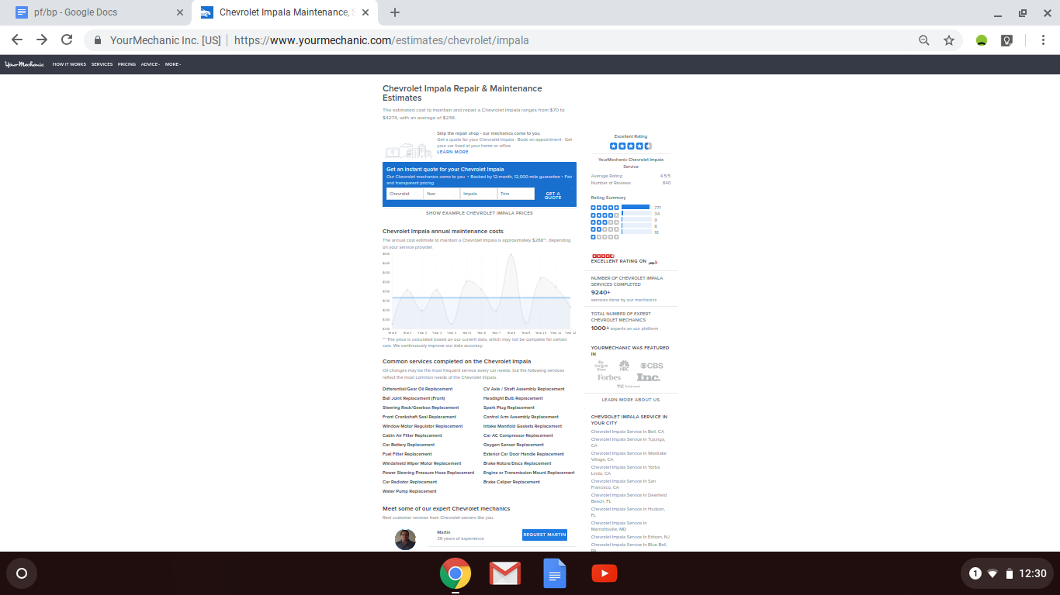
https://www.yourmechanic.com/estimates/chevrolet/impala

SAVINGS-
I will put $1000 into my savings account. My final financial goals are to be very stable and to be prepared for emergencies and events I didn’t plan on or for.
There are tiered ineterst rates for savings accounts at my bank.The rates are all listed in the image below
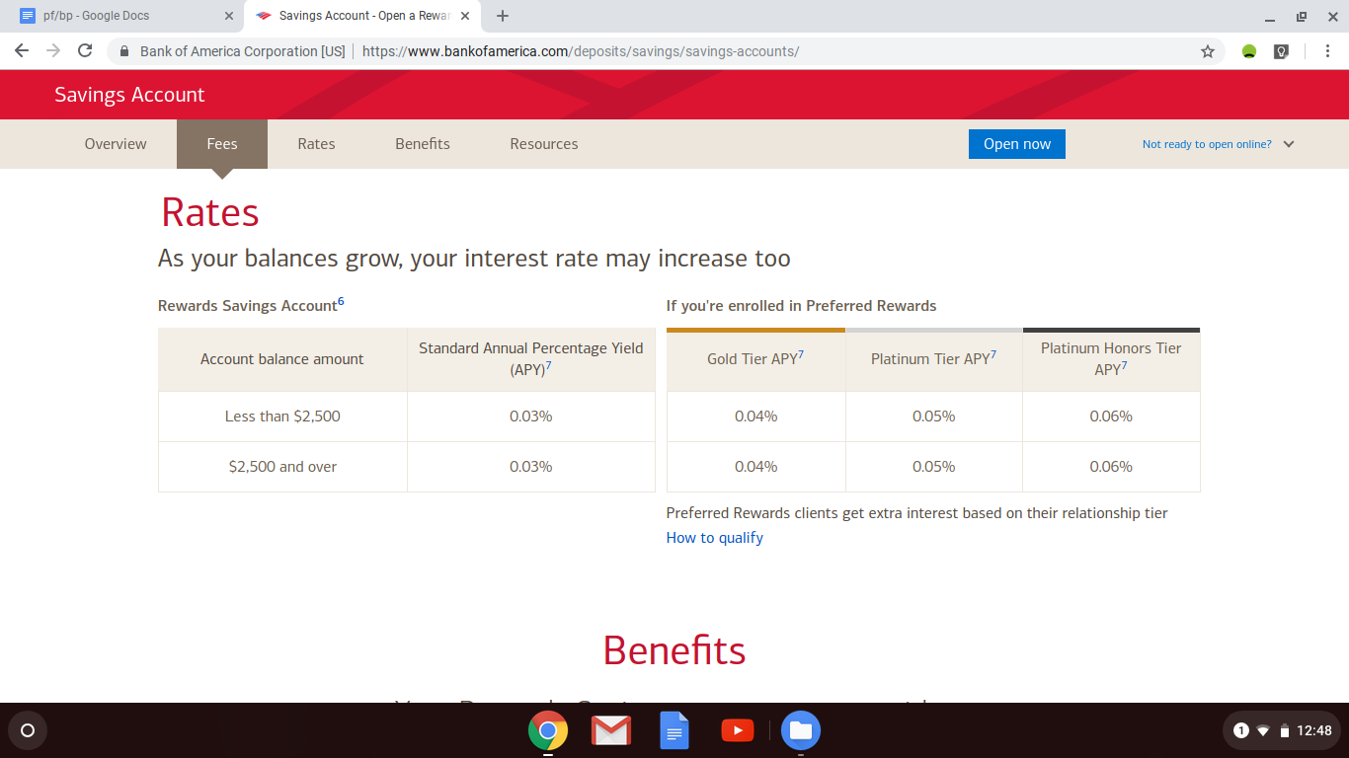
https://www.bankofamerica.com/deposits/savings/savings-accounts/

DONATIONS-
I am choosing not to give any donations and not to have any charitable expenses as I prefer to volunteer my time and give back in that way as with that way I feel that I am forming a better connection with the community and the people in it. I feel like it is more meaningful to give time than it is to give money.

